**REVIEW OF LITERATURE:**

**Fire Accidents:**

Fire accidents can result in catastrophic personal injury and devastating damage. Every year, billions of dollars in property damage occurs as a result of fire. Victims of fire accidents can suffer serious harm, including burn injury to their entire body. The Centres for Disease Control and Prevention note deaths from fires and burns are the fifth most common cause of unintentional injury and deaths in India and third leading cause of fatal home injury. Fire accidents can cause death not only from burns but also from smoke inhalation and toxic gases. Fires can be caused in a number of ways. Some fires are intentionally set. Others are accidental, such as when a barbecue is used too close to a home or a candle is knocked over. Some fires are the result of faulty appliances or old electrical wiring. According to the National Fire Protection Association, fires that start in electrical systems or lighting equipment damage more than 24,000 homes each year. These fires also kill approximately 320 people and injure 830 more every year.

**Types of Fire Accidents:**

All fire incidents can be divided in many ways depending on the cause of fire

outbreak, but broadly there are two types of fires. One is natural and other is manmade. Forest fires can be either due to natural or manmade reasons. All residential and non-residential structural fires are largely manmade. Similarly, all individual and chemical fires are due to explosions or fires made by humans or due to machine failures.

Murthy, D.B.N., “Disaster Management”, ISBN:978-81-79-2990-7-7,Deep and Deep Publications Private Limited,New Delhi.

2Shagufta, “Disaster Management”, ISBN No:978-81-31-3130-20, APH Publishing Corporation, New Delhi.

**Natural Fire Accidents:**

Fires which are considered as natural are basically earthquake, volcanic eruption and lightning generated fires. The fire and explosion risk associated with an earthquake is a very complex issue. Compared with ordinary fires, the fire and explosion hazard related to earthquakes can constitute a substantial and heavy risk. Damage to natural gas systems during an earthquake is a major cause of large fires. Again probably the most significant direct impact of power systems on fire following an earthquake is that electronic power is a major fire ignition source. In addition to dropped distribution lines, power circuits in damaged houses are another major ignition source. There have been cases

where as many as two – thirds of all ignitions after an earthquake has been attributed to power system.

**Manmade Fire Accidents:**

Fire caused by human / machine errors are considered as manmade fires, e.g. industrial or chemical fire accidents, fires at social gatherings due to electrical short circuit accidental fire and kitchen fires. Rural and urban, residential and non – residential structural fires are also largely manmade fires. Any confined fire could be due to many reasons like, cooking fire confined to container, chimney or fuel fire confined to chimney, incinerator overload or malfunction, fuel burner / boiler malfunction and trash fire.

**METHODOLOGY:**

This section is devoted to a description of the methodology, which includes sources of data, construction of interview schedule, pilot study, sampling design, collection of data, tools of analysis and the period of the study. The present study is descriptive and analytical in nature. Designing suitable methodology and selection of analytical tools are important for a meaningful analysis of any research problem. In the present study primary data were collected from the employees of the selected industries functioning in the study area. The terms ‘public’ and ‘community’ cover the different group of people of the society such as employers group, employees group, students’ community and the like. For the present study, the researcher has selected the employees’ category of selected industries which is highly affected by the fire accidents in

the study area.

**Sources of Data:**

Both primary and secondary data are used for the present study. Secondary data were collected from the various books, journals, reports, unpublished records of Department of Fire and Rescue Services, Virudhunagar Division, Tamil Nadu and various websites. Primary data were collected from the respondents selected for the present study using interview schedule.

**Research Instrument:**

Interview schedule was used by the researcher to collect primary data. The interview schedule was designed with appropriate questions to fulfil the objectives of the study. The first part captures the socio economic profile of the respondents followed by knowledge about the working industry and their nature

of work. The second part gathers details about awareness and participation level of the respondents on eight dimensions of fire accidents namely, general awareness about fire accidents, awareness about identifying the fire hazards, awareness about the people who could be at risk, awareness about control the fire hazards, awareness about emergency evacuation plan, awareness about protection during fire accidents, awareness on post fire accidents and awareness level about participation to mitigate the fire accidents. The face and content validity is finalised after making consultation with the experts. Based on

their feedback, changes were made and it is found that all the items developed by the researcher in the interview schedule is having adequate validity for analysing the community participation and awareness towards fire accidents.

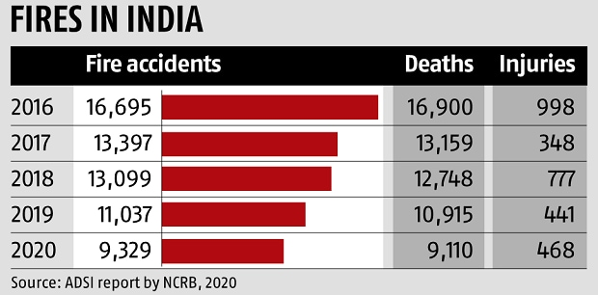

The first generation of fire detection devices (1849-1940) was based on thermal detectors. But the start of fire alarm systems development began with the invention of the telegraph by Samuel F. B. Morse in 1844. The first practical fire detection systems using telegraph, was developed in U. S. by Dr. William Channing and Moses G. Farmer in 1852. Two years later, he applied for a patent for his electromagnetic telegraph fire protection system intended to be used in cities. In Europe in 1848 the first fire alarm device was developed by C.A. von Steingel, which was operated by the firemen and used button switches and different kinds of bells to give prearranged audio signals. The first telegraph device was created three years later in Berlin and as fire alarm telegraph equipment, used a cable connection, to alert total of 37 fire stations. The development of the first temperature sensors started with the introduction of bimetallic sensors in the 19th century. The working principle of these sensors was based on the unequal expansion between the two metal stripes. These relays were reliable and durable, and are still considered ideal for many industrialapplications.  
  
**Smoke Detectors**: Fire smoke detectors are most critical and front end component of any fire detection & alarm system. These front end sensors have also evolved over the time and its’ their advancement which has contributed in making conventional fire alarm System, intelligent & smart-because without these smart, fast, reliable and addressable front line sensors, no fire alarm system could have been made smart or intelligent. The evolution of these frontline sensors can be divided into four generations based on their developments, improvement, and merging with the electronic technology industry.